Name: Barnachia, John Philip M. Cr. and Yr.: BSCS – 2B

**Wireframe**

**Homepage**

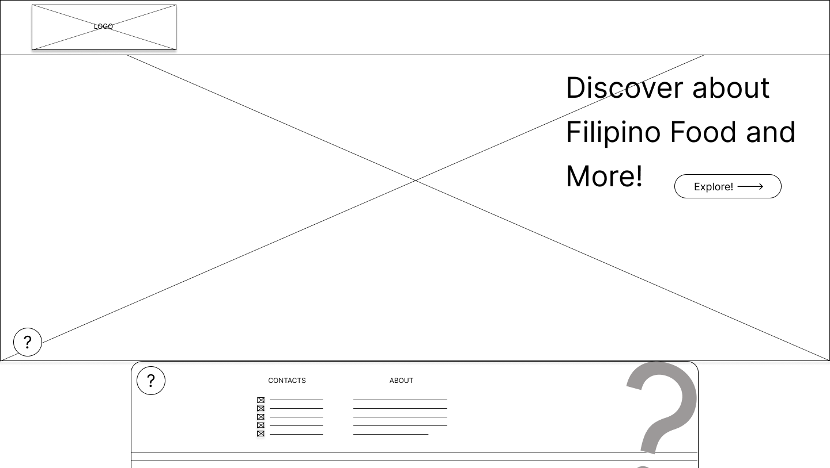

**Dish Info**

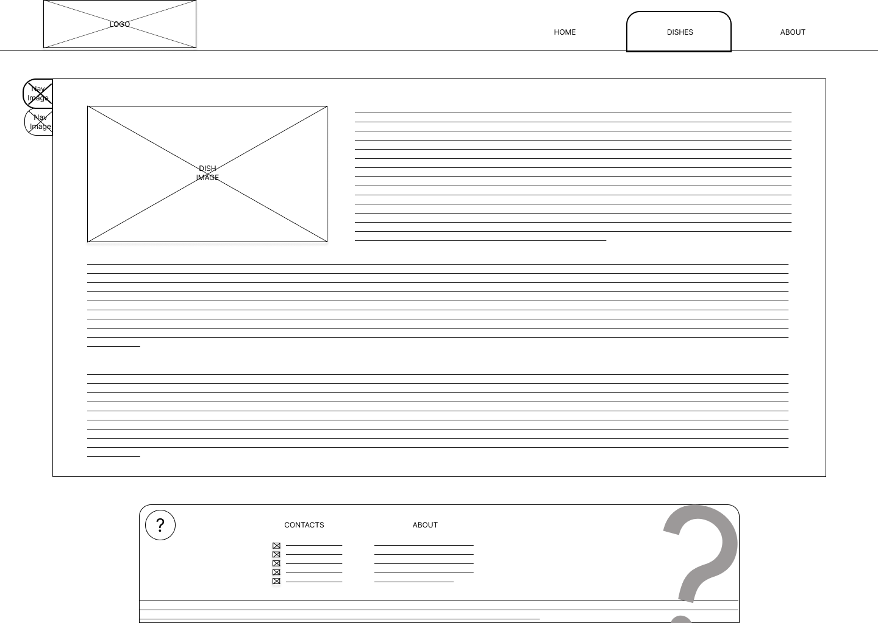

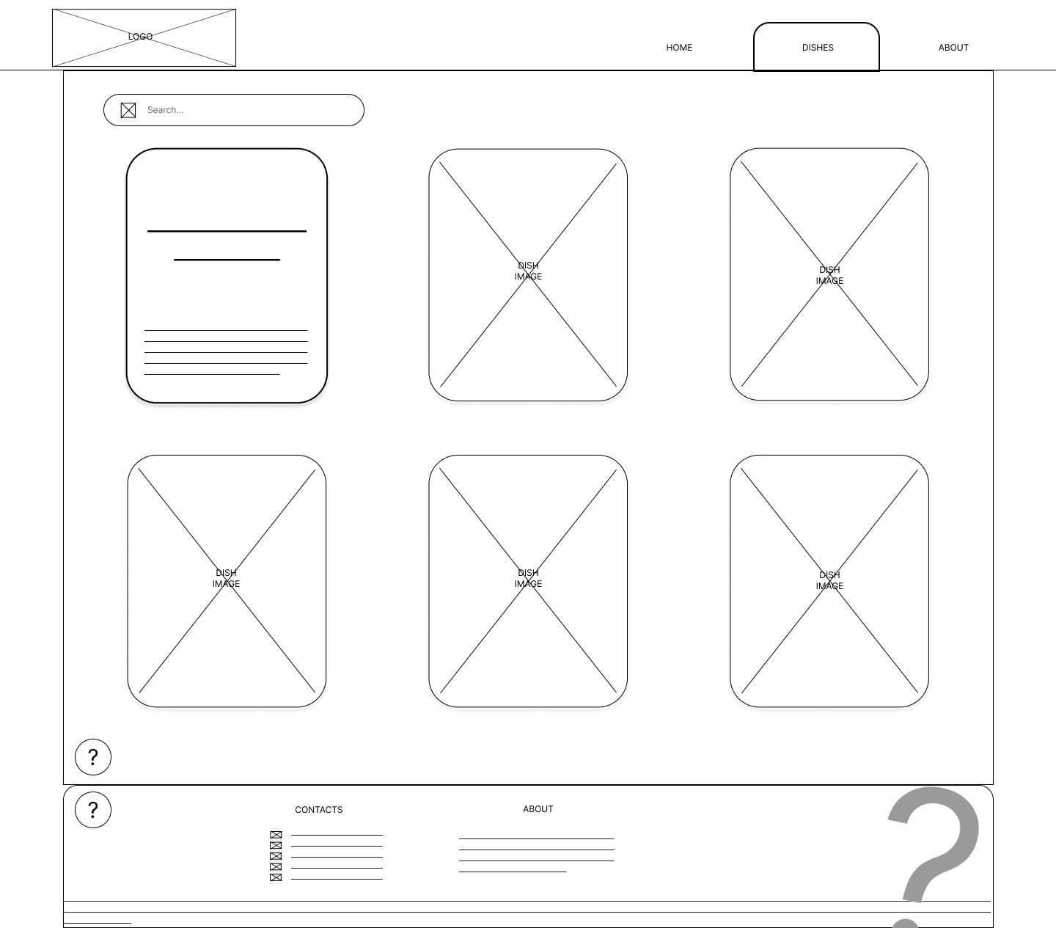**Dish List Page**